Step 0 Intake + Interview Filing Status, Dependency

Interview Notes: (See also: General Notes)
- Andrea paid $1,000.00/month rent for the tax year.

Documents:
711-xx-yyyy
Andrea AndersOn
Andrea Anderson

Step 1 Basic Information

TP Form / Note | TS Screen | Notes
 | Basic Information – Filing Status
Intake Sheet | What is your filing Status? | Select Filing status from drop down.  Answer: Filing Status: Single  Continue
SS Card  Intake Sheet  G-Note 2 | Personal Information  Taxpayer Information  Address & Phone Number | Hint: Use Name and SSN from SS card. (Not Intake Sheet)  Hint: SSN format YYY-00-0752  TS: Birth date can be entered using drop down menu or filling in the field.  TS: Check any of the “Check here” questions that apply –  TS: Enter Zip code- TaxSlayer fills in city and state. Correct if required  TS: Enter New Jersey as the Resident State  TS: Select Continue
Intake Sheet  G-Note 3 | Just a Few More Questions (NJ Info) | TS: Select Municipality from drop down menu (Listed by county). Start typing Bergen to quickly scroll down. Select Edgewater Boro.  TS: Select Yes or No for the Gubernatorial Election Fund. See Intake Sheet page 3 and General Note 3. Answer: No for TP,  TS: Enter Five Digit Pin for TP. Any 5-digit number.  TS: Select Continue
 | Dependents/ Qualifying Person  Do you have any Dependents or Qualifying Person(s) to claim on your return? | TS: Answer is “No”

Federal Refund: 0 NJ Refund Amount: 0

Step 2 W-2 Billings Market

W-2  Billings Market | Left Menu – Federal Section  Enter Myself  Wages & Salaries Form W-2  Begin | Hint: Make corrections so that information matches the information on the W-2  Hint: If the name and address of the employer come up after inputting the employer Identification Number, check that the information is correct  Hint: Always round up for amounts ending in --.50  Hint: Box 14 NJ Codes are selected from drop down menu. All other entries in box 14 are lumped under “Other”  Hint: If NJ State EIN auto populates, check to be sure it is correct  TS: Click continue NJ warning  TS: Click Continue back to income

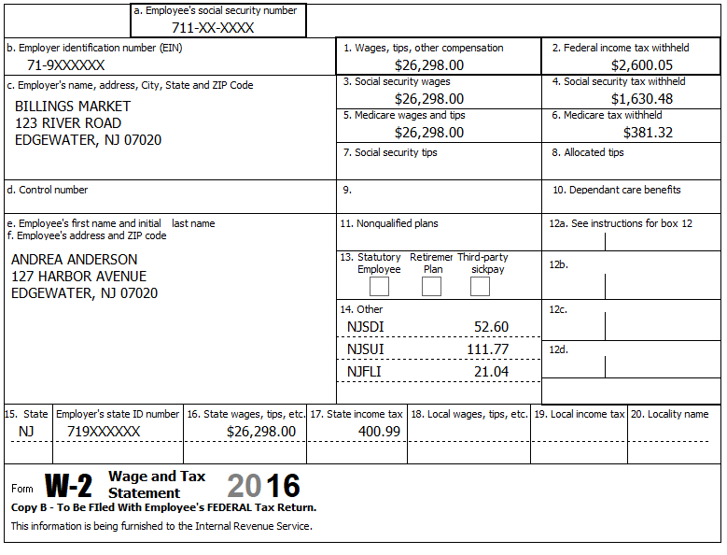
2015
2014
Federal Refund: 675 NJ Refund Amount: 29

Step 3 Interest 1099-INT

TP Form / Note | TS Screen | Notes
1099-INT  Big City Bank | Income  Interest and Dividends Form 1099-INT/ 1099-DIV- Begin  Interest or Dividend Income -Begin  Interest Income, Form 1099-INT,Form 1099-OID…..  Continue | Enter values that apply  Continue -

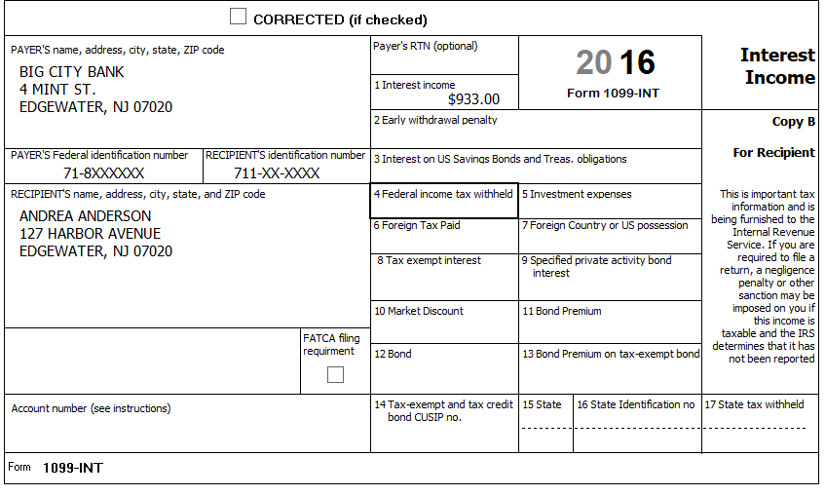

Federal Refund: 532 NJ Refund Amount: 12
Step 4 Federal Deductions, Adjustments & Credits
TP Form / Note | TS Screen | Notes
 | Left Menu – Federal Section  Deductions  Enter Myself  Itemized Deductions – Begin  Taxes You Paid | Go to the Sales Tax Worksheet and enter NJ, Zip Code, and 366 days living in the state  Continue back to Health Insurance
 | Compare Standard vs Itemized Deductions  Left Menu - Federal Section  Deductions  Enter Myself  Compare Deductions - Begin | Check to see if using itemized deductions or standard deductions.  Itemized =587 Std = 6,300  Continue

Federal Refund: 532 NJ Refund Amount: 12

Step 5 Health Insurance
TP Form / Note | TS Screen | Notes
G-Note 2 | Left Menu-Health Insurance  Start Questionnaire | Answer questions in the Health Insurance Section

Andrea had health insurance that met Minimum Essential Coverage rules for the entire year. She did not purchase it through the marketplace.
Federal Refund: 532 NJ Refund Amount: 12

Step 6 New Jersey Return

TP Form / Note | TS Screen | Notes
I-Note 1  G-Note 2,3,4 | State Return –Edit  Enter Myself  Basic Information  Credits  Property Tax/Deduction | Hint: Use the NJ Checklist to enter NJ items  HINT: Check Basic Information – Default values will not appear as selected  Continue  Answer questions  Hint: Use scratch pad at TP4F to determine the proper value for Property Tax Paid  Hint: Property Taxes Paid = (rent*.18) 12,000x.18= 2,160  Hint: Taxpayer meets Property Tax Eligibility Requirements  Hint: Were you a homeowner in 2016 - No  Continue back to the beginning of the State Return

Andrea paid $1,000.00/month rent for the tax year.

Federal Refund: 532 NJ Refund Amount: 62

Step 7 Prepare for e-file

Intake Sheet  G Note 5,9,  Supplemental Intake Sheet | Left Menu – e-file – | TS – Clear up any diagnostic messages (if any)  TS: Select Federal Return Type “E:file: Paper Check”  TS: No entries in Fees section except for Client email address  TS – Pin numbers for e-file are automatically selected  TS: Select State Refund Type “E:file: Paper Check”  TS: Skip Third Party Designee Info  TS – Questions – Answer questions from Intake sheet Part VII, lines 5.6 and 7, Supplemental Intake Sheet,  TS: Skip TP ID Information Screen  Save  You are Done

She wants to handle any state refund / amount due like their federal refund / amount due.
She did not have any out-of-state purchases on which they did not pay use tax.

Federal Refund: 532 NJ Refund Amount: 62

